Birla Institute of Technology & Science, Pilani
Work Integrated Learning Programmes Division
First / Second Semester 20**-20**

Mid-Semester Test
(EC-2 Regular)

Course No. : AIMLCZG565
Course Title : Machine Learning
Nature of Exam : Closed Book
Weightage : 30%
No. of Pages = 3

No. of Questions = 5
Duration : 2 Hours
Date of Exam : **** (FN/AN)
Note to Students:
- Please follow all the Instructions to Candidates given on the cover page of the answer book.
- All parts of a question should be answered consecutively. Each answer should start from a fresh page.
- Assumptions made if any, should be stated clearly at the beginning of your answer.

- [10 Marks]
An IPL franchise wants to predict whether a team will qualify for the playoffs based on its performance in the league stage (8 matches). The analyst has collected the following data for 5 teams:
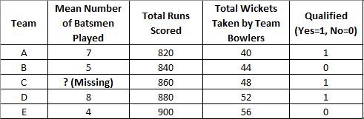
This dataset will be used as the training data for building a logistic regression model. One value is missing in the feature “Mean Number of Batsmen Played.”
(a) Suggest appropriate methods to handle the missing value in the Mean Number of Batsmen Played feature before building the logistic regression model. Justify your choice. (1 marks)
(b) Normalize only the Total Runs and Total Wickets features using z-score normalization.
Show the formula, compute the mean and standard deviation, and present the updated dataset. (3 marks)
c) On the normalized dataset, perform one iteration of Batch Gradient Descent to update the weights for the logistic regression model, using:
- Initial weights: θ = [0.1, 0.1, 0.1, 0.2]
- Learning rate: α = 0.1 (4 marks)
d) Calculate the value of the Cross-Entropy Loss (Log loss) function at the end of the first iteration (1 mark)
e) Calculate and interpret the predicted probability of playoff qualification for Team D after the first iteration. (1 mark)

- [3 Marks]
A student claims:
“I doubled my dataset size, but my validation RMSE still stayed high while the training RMSE kept dropping. Therefore, increasing dataset size doesn’t help.”
As an instructor, critique this statement using the concepts of model complexity, bias–variance trade-off, and training - validation behavior.
a) Comment whether the model has (low / high) Bias and (low / high) Variance (0.5 marks for each).
b) Include one likely reason this observation occurred. (1 mark)
c) Suggest one corrective action for the above. (1 mark)

- [8 Marks]
- Consider the training dataset provided in the table below, which tracks the purchasing behaviour of customers based on Agegroup, Income Level, and Occupation.
- Calculate the Entropy of the target class Purchased for the entire dataset. (2 Marks)
- Suppose we choose "Agegroup" as the root node. This creates three branches. Calculate the Entropy specifically for the "Young" branch. Is this branch pure? If not, which attribute would you use next to split this specific "Young" node to achieve pure leaf nodes? (3 Marks)
- Compare the attributes "Occupation" and "Income Level". Without performing full Information Gain calculations, argue which of these two attributes appears to separate the "Yes" and "No" classes more effectively. (2 Marks)
- A new customer walks in with the profile: {Age: Young, Income: Low, Occupation: Professional}. Based only on the majority voting of the "Young" subset in the training data, how would this customer be classified? (1 Mark)
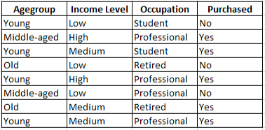

- [5 Marks]
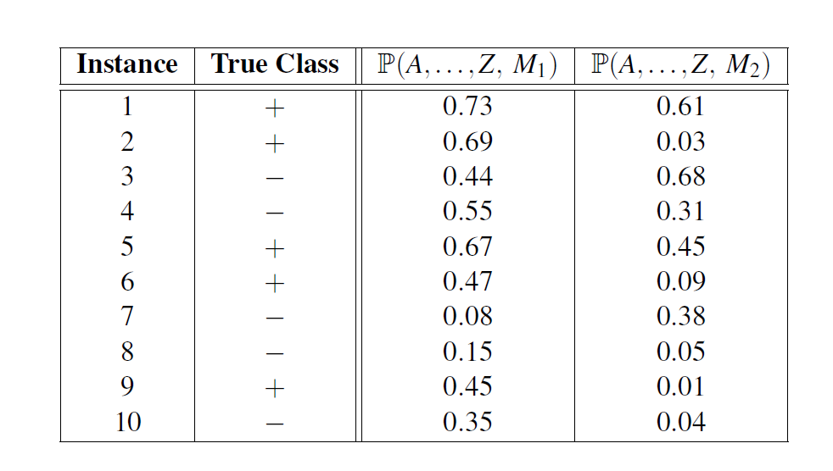
You are asked to evaluate the performance of two classification models, M₁ and M₂. The test set you have chosen contains 26 binary attributes, labeled as A through Z.
The above table shows the posterior probabilities obtained by applying the models to the test set. (Only the posterior probabilities for the positive class are shown). As this is a two-class problem, P(−) = 1−P(+) and P(− | A,...,Z) = 1−P(+ | A,...,Z). Assume that, we are mostly interested in detecting instances from the positive class.
For both models, M₁ and M₂, suppose you choose the cutoff threshold to be t = 0.5. In other words, any test instances whose posterior probability is greater than t will be classified as a positive example.
  - Construct the Confusion Matrix for both models (2 marks)
  - Compute the precision, recall, and F-measure for both models at this threshold value. (3 marks)

- [4 Marks]
- In a regression model predicting house price = 50 + 200×(area) + 5×(age),
a) Interpret both coefficients. (1 mark)
b) What happens if we change the units of “area” from m² to ft²? (1 mark)
- In gradient descent, ∂J/∂θ₁ is large while ∂J/∂θ₂ is near zero. From this, what can you infer about the model parameters? (1 mark)
- Which feature has a stronger influence on house price—area or age? Justify. (1 mark)

***********

